## **Refid: 2, An Empirical Investigation of Filter Attribute Selection Techniques for High-Speed Network Traffic Flow Classification**

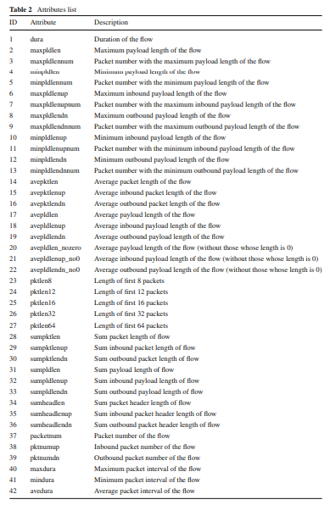

## **Refid: 8, Dynamic Network Traffic Data Classification for Intrusion Detection Using Genetic Algorithm**

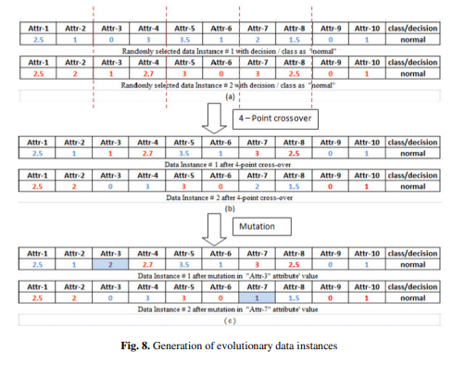

## **Refid: 9, Feature Selection in the Corrected KDD-dataset**

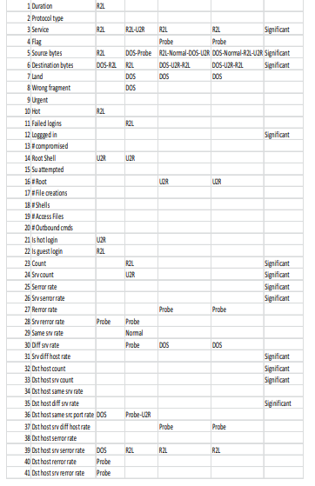

## **Refid: 12, Data Summarization for Network Traffic Monitoring**

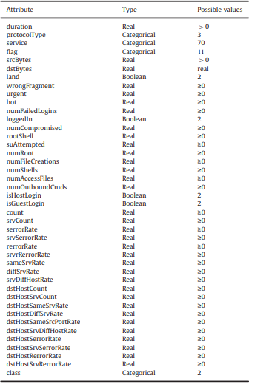

## **Refid: 13, Hybrid Classifier Systems for Intrusion Detection**

Not Provided

## **Refid: 18, Decentralized Detection of Network Attacks Through P2P Data Clustering of SNMP Data**

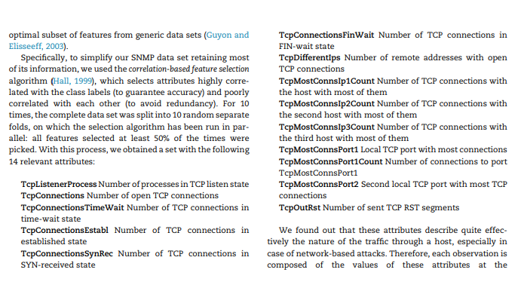

## **Refid: 24, Payload Modeling for Network Intrusion Detection Systems**

Not Provided

## **Refid: 32, Towards the Reduction of Data Used for the Classification of Network Flows**

Not Provided

## **Refid: 47, An Intrusion Detection System Using Network Traffic Profiling and Online Sequential Extreme Learning Machine**

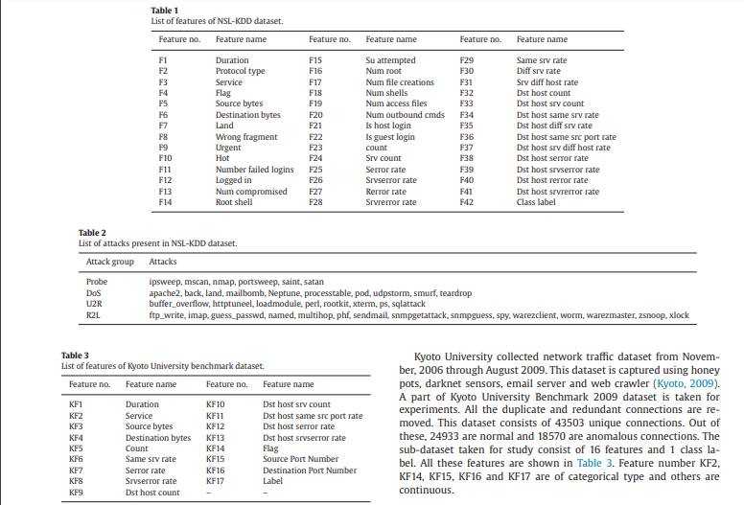

## **Refid: 48, A Multi-step Outlier-based Anomaly Detection Approach to Network-wide Traffic**

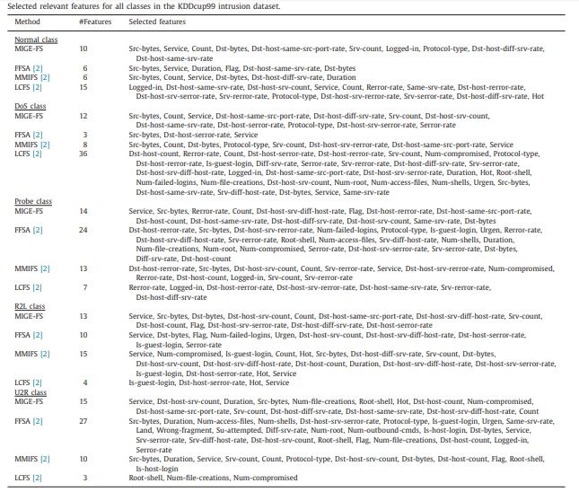

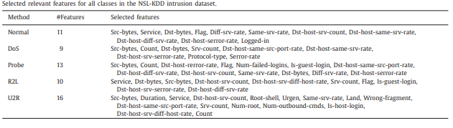

## **Refid: 50, Characterizing Network Traffic by Means of the NetMine Framework**

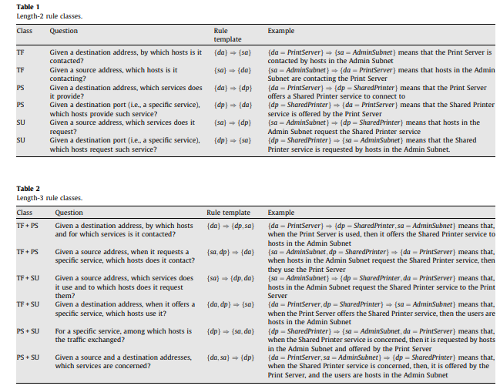

## **Refid: 51, An In-depth Analysis on Traffic Flooding Attacks Detection and System Using Data Mining Techniques**

## 

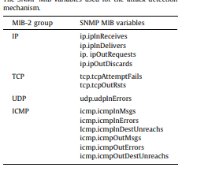

## **Refid: 52, A Framework for Application-driven Classification of Data Streams**

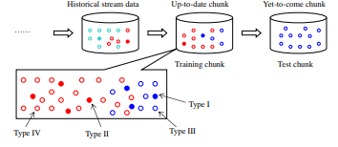

## **Refid: 53, History Guided Low-Cost Change Detection in Streams**

Not avilable

## **Refid: 56, Detecting Anomalies from Big Network Traffic Data Using an Adaptive Detection Approach**

The extracted features included the basic features of an individual TCP connection such as its duration, protocol type, number of bytes transferred, and the flag/label indicating the normal or error status of the connection. Other features of an individual connection were obtained by using some domain knowledge and include the number of file creation operations, number of failed login attempts, where root shell was obtained and others. Finally, there were a number of features computed using a two-second time window. These include the number of connections to the same host as the current connection within the past two seconds, percentage of connections that have ‘‘SYN’’ and ‘‘REJ’’ errors, and the number of connections to the same service as the current connection within the past two seconds. In total, there are 42 features for this data set. In addition, labeled training and test data sets are available in this application. They are the data collected in the first seven weeks of the DARPA experiments.

## **Refid: 58, RFAODE: A Novel Ensemble Intrusion Detection System**

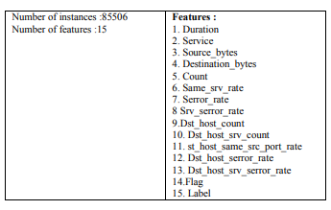

## **Refid: 59, A Data Mining Framework for Securing 3G Core Network from GTP Fuzzing Attacks**

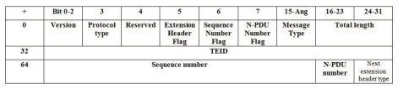

## **Refid: 63, Local Outlier Factor and Stronger One Class Classifier Based Hierarchical Model for Detection of Attacks in Network Intrusion**

Not Provided

## **Refid: 64, Intrusion Detection with Evolutionary Learning Classifier Systems**

Not Provided

## **Refid: 69, Peer-to-Peer Traffic Identification by Mining IP Layer Data Streams Using Concept-Adapting Very Fast Decision Tree**

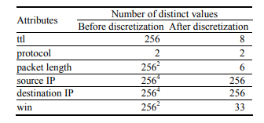

## **Refid: 74, Online Incremental Learning for High Bandwidth Network Traffic Classification**

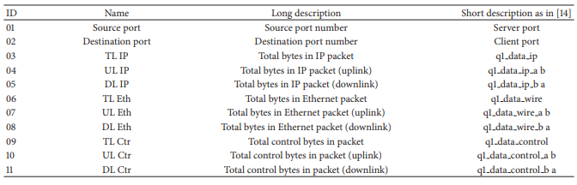

## **Refid: 109, An Integrated Model for Prediction of Loading Packets in Network Traffic**

Not provided

## **Refid: 133, Sub-space Clustering, Inter-clustering Results Association & Anomaly Correlation for Unsupervised Network Anomaly**

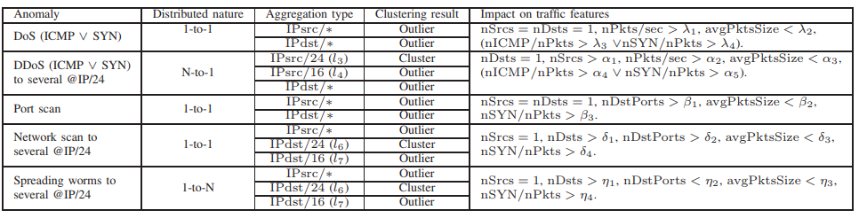

## **Refid: 134, Relational Network-service Clustering Analysis with Set Evidences**

Not Provided

## 

## 

## **Refid: 149, Automatic Discovery of Botnet Communities on Large-scale Communication Networks**

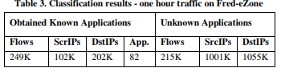

## **Refid: 166, An Autonomic Traffic Analysis Proposal Using Machine Learning Techniques**

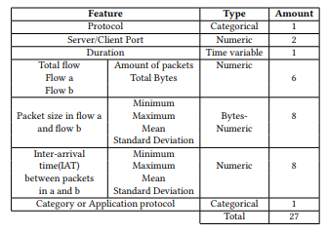

## **Refid: 167, A Supervised Machine Learning Approach to Classify Host Roles on Line Using sFlow**

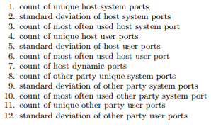

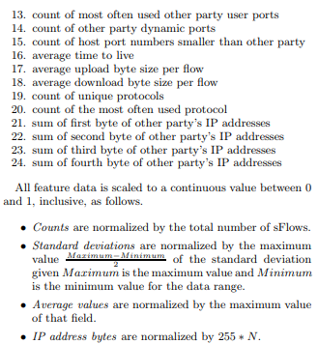

## **Refid: 168, Machine Learning for Encrypted Malware Traffic Classification: Accounting for Noisy Labels and Non-Stationarity**

Not Provided

## **Refid: 169, Causality-based Sensemaking of Network Traffic for Android Application Security**

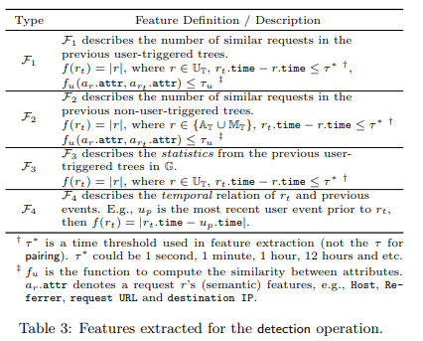

## **Refid: 171, A Preliminary Investigation on the Identification of Peer to Peer Network Applications**

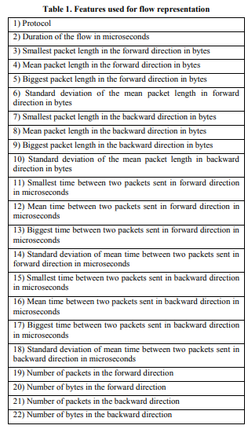

## **Refid: 173, BotFinder: Finding Bots in Network Traffic Without Deep Packet Inspection**

Avg Time Interval

Avg duration of Connection

The avg number of source bytes and destination bytes per flow

The Fast Fourier Transformation (FFT)

## **Refid: 180, When Smartphones Become the Enemy: Unveiling Mobile Apps Anomalies Through Clustering Techniques**

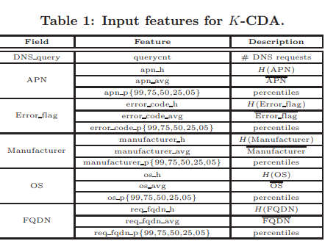

## **Refid: 183, Radio Frequency Traffic Classification Over WLAN**

## 

## **Refid: 185, Identifying Encrypted Malware Traffic with Contextual Flow Data**

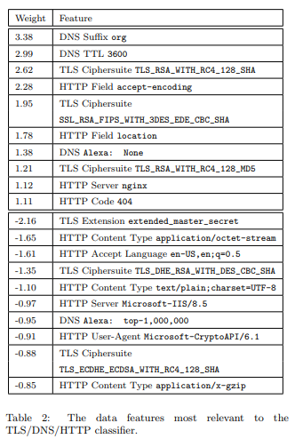

## **Refid: 188, Robust Network Traffic Identification with Unknown Applications**

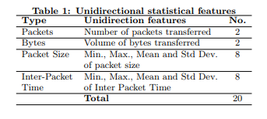

## **Refid: 195, Passive Classification of Wi-Fi Enabled Devices**

Inter-Probe Period (IPP)

Received Signal Strength (RSS)

Coefficients of variation

Number of probe requests with broadcast/known SSID

Device manufacturer

## **Refid: 196, A Modular Machine Learning System for Flow-Level Traffic Classification in Large Networks**

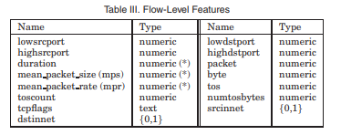

## **Refid: 199, Network planning tool based on network classification and load prediction**

Not Provided

## **Refid: 202, Iterative-tuning support vector machine for network traffic classification**

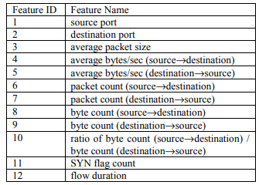

## **Refid: 208, CluClas: Hybrid clustering-classification approach for accurate and efficient network classification**



## **Refid: 213, An Effective Network Traffic Classification Method with Unknown Flow Detection**

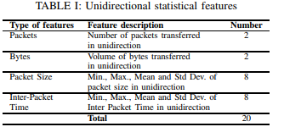

## **Refid: 217, TCFOM: A Robust Traffic Classification Framework Based on OC-SVM Combined with MC-SVM**

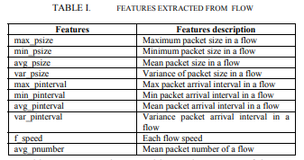

## **Refid: 219, Network traffic classification using AdaBoost Dynamic**

time stamp

IP source

IP destination

transport port source

transport port destination

DPI label(s)

application name

transport protocol

## **Refid: 222, A Biologically-Inspired Approach to Network Traffic Classification for Resource-Constrained Systems**

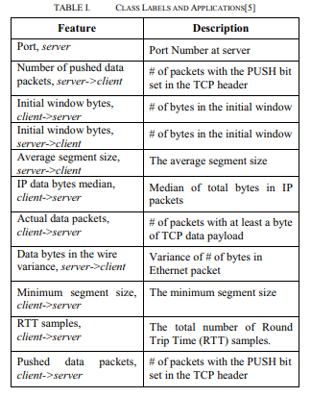

## **Refid: 232, Comparative study of a Hybrid Model for network traffic identification and its optimization using Firefly Algorithm**

DataLength (referring to the datagram length field)

Flag (associated with the flags field)

Lay (associated with the upper layer protocol field)

TcpLength (relative to the packet payload size (TCP))

SegmentLength (relative to the packet payload size (UDP))

## **Refid: 235, Network data classification using graph partition**

Not Provided

## **Refid: 237, An approach for classification of network traffic on semi-supervised data using clustering techniques**

Not Provided

## **Refid: 240, Multi Level Statistical Classification of Network Traffic**

The parameters include:

IP address

Port Number

Packet Transmission Rate (Received and Transmitted packet)

Data Rate (Received and Transmitted bytes)

Inter-arrival time, Packet Size

The unlabelled data is collected using the Wireshark tool and given as an input to Unsupervised K-means for clustering.

## **Refid: 240, Multi Level Statistical Classification of Network Traffic**

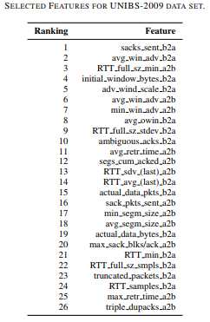

## **Refid: 243, Network traffic classification in encrypted environment: A case study of Google Hangout**

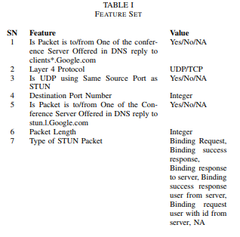

## 

## **Refid: 248, Adaptive framework for network traffic classification using dimensionality reduction and clustering**

Not Provided

## **Refid: 249, Deep neural network based malware detection using two dimensional binary program features**

Not Available

## **Refid: 251, Two-phased method for identifying SSH encrypted application flows**

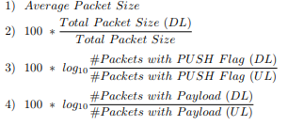

## **Refid: 253, Early detection of VoIP network flows based on sub-flow statistical characteristics of flows using machine learning**

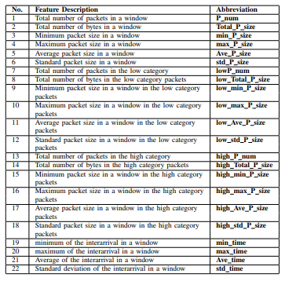

## **Refid: 254, A Parallelized Network Traffic Classification Based on Hidden Markov Model**

Not Provided

## **Refid: 260, Unknown malware detection using network traffic classification**

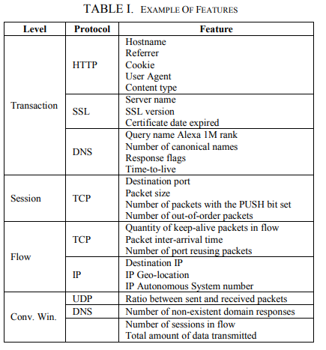

## **Refid: 261, GPU-oriented stream data mining traffic classification**

flow duration

source address

source port

destination address

destination port

protocol number

flow volume

number of frames

mean inter-arrival time

## **Refid: 264, Classification in dynamic streaming networks**

Not Provided

## 

## **Refid: 267, Implementation of network traffic classifier using semi supervised machine learning approach**

Packet size

number of packet

inter arrival time

## **Refid: 269, Classification of network traffic in LAN**

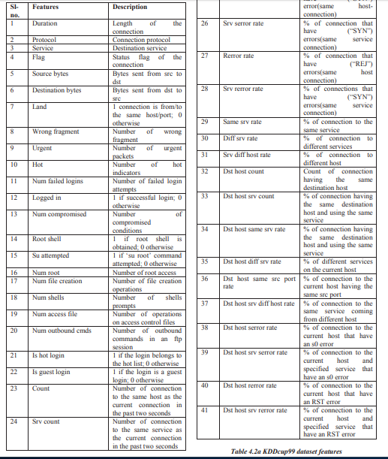

## **Refid: 282, BalancedBoost: A hybrid approach for real-time network traffic classification**

Not provided

## **Refid: 286, Network Traffic Classification Using Tri-training Based on Statistical Flow Characteristics**

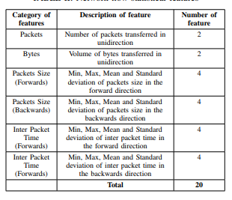

## **Refid: 292, A novel semi-supervised approach for network traffic clustering**

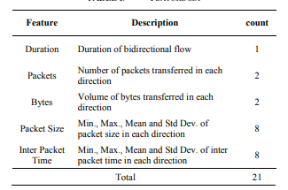

## **Refid: 294, Incremental high throughput network traffic classifier**

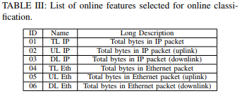

## **Refid: 297, Investigation of machine learning based network traffic classification**

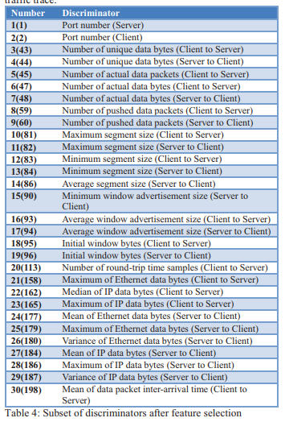

## **Refid: 304, EnClass: Ensemble-Based Classification Model for Network Anomaly Detection in Massive Datasets**

Not Provided

## **Refid: 306, Network Traffic Classification Using Correlation Information**

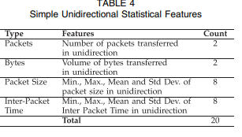

## **Refid: 308, A self-adaptive network traffic classification system with unknown flow detection**

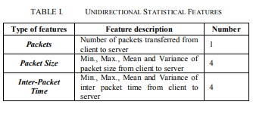

## **Refid: 311, Dynamic online traffic identification scheme based on data stream clustering algorithm**

Protocal_type

Num_failed_logins

Logged_in

Num_compromised

Is_guest_login

count, srv_count

Dst_host_srv_count

St_host_same_srv_rate

dst_host_diff_srv_rate

Dst_host_srv_rerror_rate

## **Refid: 313, Identification in Encrypted Wireless Networks Using Supervised Learning**

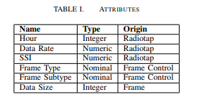

## **Refid: 317, Comprehensive Analysis of Network Traffic Data**

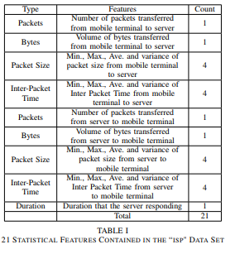

## **Refid: 323, Traffic Identification in Semi-known Network Environment**

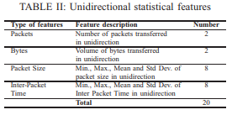

## **Refid: 328, Metrie learning with statistical features for network traffic classification**

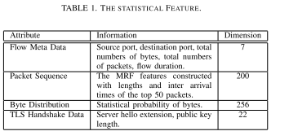

## **Refid: 333, Robust Network Traffic Classification**

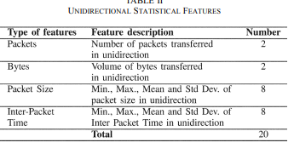

## **Refid: 336, P2P traffic classification using clustering technology**

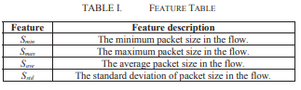

## **Refid: 342, SMILER: Towards Practical Online Traffic Classification**

packet size

inter-arrival times

inter-packet correlations

## **Refid: 352, The evaluation measure study in network traffic multi-class classification based on AUC**

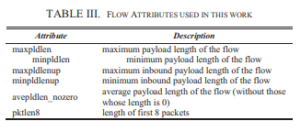

## **Refid: 353, WekaTIE, a traffic classification plugin integrating TIE and Weka**

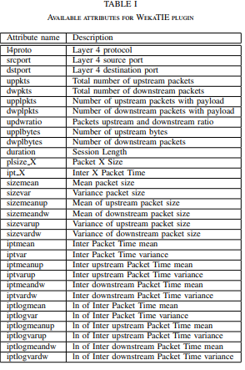

## **Refid: 354, Harvesting unique characteristics in packet sequences for effective application classification**

Packet-level Data Formatting and Flow-level Data Formatting

## **Refid: 357, A Heuristic-Based Co-clustering Algorithm for the Internet Traffic Classification**

Not Provided

## **Refid: 360, Network Traffic Classifier With Convolutional and Recurrent Neural Networks for Internet of Things**

source port

destination port

the number of bytes in packet payload

TCP window size

interarrival time

direction of the packet

## **Refid: 363, Network classification using adjacency matrix embeddings and deep learning**

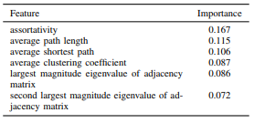

## **Refid: 375, Network traffic classification using machine learning algorithms**

Not Provided

## **Refid: 392, Internet traffic classification based on flows' statistical properties with machine learning**

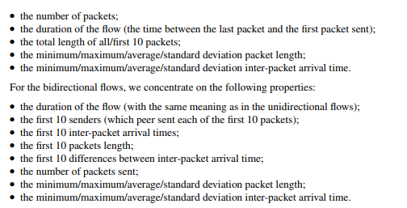

## **Refid: 400, A comparison of supervised machine learning algorithms for classification of communications network traffic**

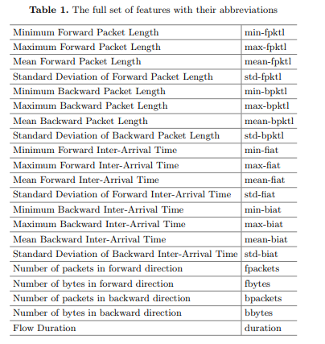

## **Refid: 412, An entropy based encrypted traffic classifier**

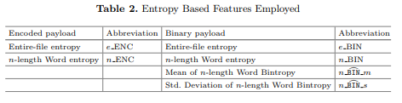

## **Refid: 418, Improved classification of known and unknown network traffic flows using semi-supervised machine learning**

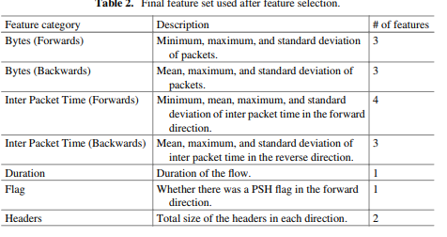

## **Refid: 419, Hybrid multi-objective optimization approach for neural network classification using local search**

Not Provided

.

## **Refid: 433, A preliminary investigation on the identification of peer to peer network applications**

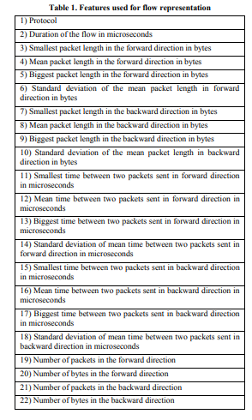

## **Refid: 439, Real-time multi-application network traffic identification based on machine learning**

Not Provided

## 

## **Refid: 452, Analysis of Early Traffic Processing and Comparison of Machine Learning Algorithms for Real Time Internet Traffic**

packet length (min, max, mean, sd)

payload length (min, max, mean, sd)

Inter-arrival time (min, max, mean, sd)

flow duration (min, max, mean, sd)

## **Refid: 453, On addressing the imbalance problem: A correlated KNN approach for network traffic classification**

src-ip, src-port, dst-ip, dst-port and protocol

## **Refid: 489, TrafficS: A behavior-based network traffic classification benchmark system with traffic sampling functionality**

Not Provided

## **Refid: 547, Better network traffic identification through the independent combination of techniques**

number of packets, flow size, flow duration, average rate and port numbers

## **Refid: 548, An accurate traffic classification model based on support vector machines**

Not Provided

## **Refid: 549, Network Traffic Classification using Genetic Algorithms based on Support Vector Machine**

Not Provided

## **Refid: 560, A novel semi-supervised learning method for Internet application identification**

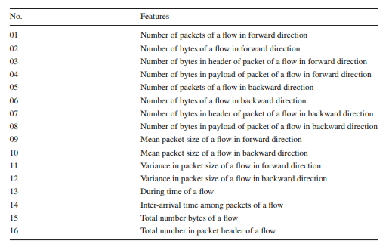

## **Refid: 569, Ensemble network traffic classification: Algorithm comparison and novel ensemble scheme proposal**

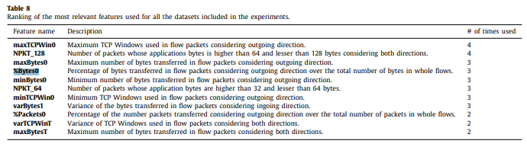

## **Refid: 577, Waterfall: Rapid Identification of IP Flows Using Cascade Classification**

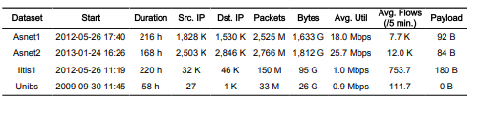

## **Refid: 583, Network traffic classification based on ensemble learning and co-training**

Not Provided

## **Refid: 598, High-Performance Internet Traffic Classification Using a Markov Model and Kullback-Leibler Divergence**

packet size, packet direction, and packet inter-arrival time

## **Refid: 603, Network traffic classification via non-convex multi-task feature learning**

## 

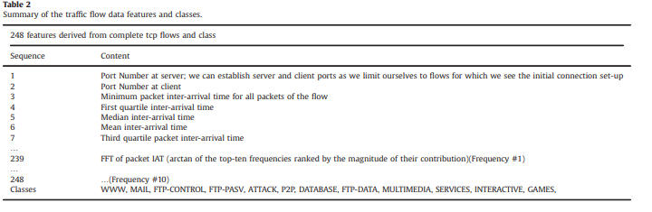

## **Refid: 610, SmoteAdaNL: a learning method for network traffic classification**

Not Provided

## **Refid: 611, A class-oriented feature selection approach for multi-class imbalanced network traffic datasets based on local and global metrics fusion**

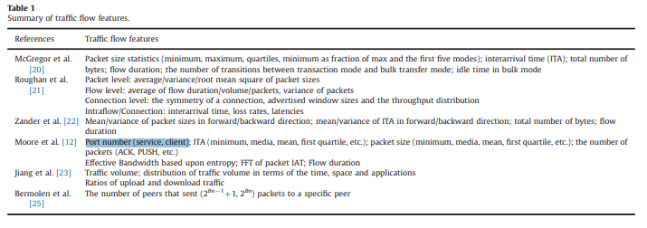

## **Refid: 618, Encrypted Traffic Classification Using Statistical Features**

Packet length distribution

the idle time between streams

inter arrival time of the packets

the length of the packets

## **Refid: 644, Effective Packet Number for 5G IM WeChat Application at Early Stage Traffic Classification**

Not Provided

## **Refid: 660, Machine learning algorithms for accurate flow-based network traffic classification: Evaluation and comparison**

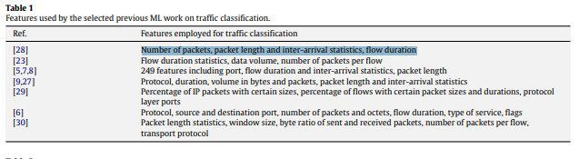

## **Refid: 663, Using clustering to improve the KNN-based classifiers for online anomaly network traffic identification**

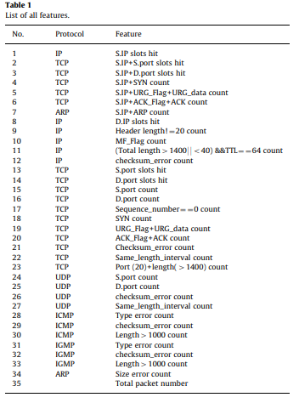

.**Refid: 664, NTCA: A High-Performance Network Traffic Classification Architecture**

mean packet length

maximum and minimum packet length

mean inter-arrival time of packets

maximum and minimum inter-arrival time of packets

flow duration

the size of the first six packets

## **Refid: 676, Internet traffic classification based on flows' statistical properties with machine learning**

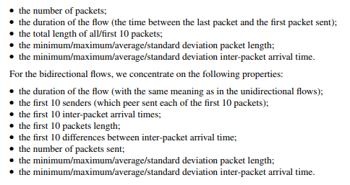

## **Refid: 689, On Evaluating Multi-class Network Traffic Classifiers Based on AUC**

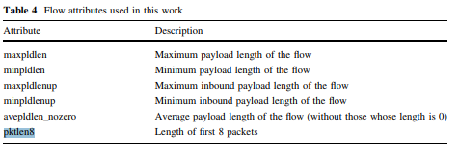

## **Refid: 691, An SVM-based machine learning method for accurate internet traffic classification**

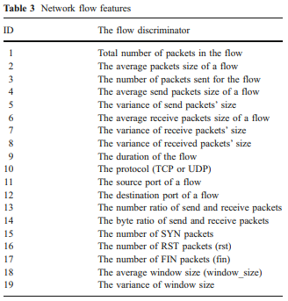

## **Refid: 704, Metric Learning With Statistical Features For Network Traffic Classification**

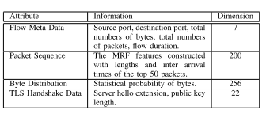

## **Refid: 707, Network Traffic Classification Model Based on MDL Criterion**

Date, Duration, Type, Packets, size, Payload

## **Refid: 710, Internet Traffic Classification Demystified: On the Sources of the Discriminative Power**

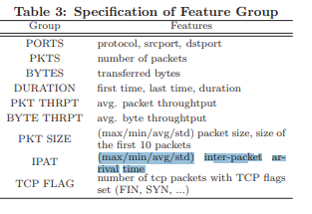

## **Refid: 718, Early Traffic Classification Using Support Vector Machines**

Not Provided

## **Refid: 724, Challenging Statistical Classification for Operational Usage: The ADSL Case**

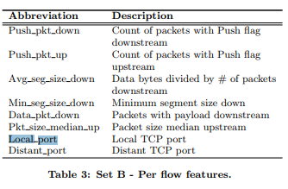

## **Refid: 725, MINETRAC: Mining Flows for Unsupervised Analysis & Semi-supervised Classification**

Not Provided

## **Refid: 727, Rapid Identification of Skype Traffic Flows**

Not Provided

## 

## **Refid: 729, High Throughput and Programmable Online Trafficclassifier on FPGA**

Protocol,Src. Port Number,Dest. Port Number,, Sizes of First N Packets, Avg. Packet Size, Max. Packet Size, Min. Packet Size, Var. of Packet Size

## 

## **Refid: 738, Timely and Continuous Machine-learning-based Classification for Interactive IP Traffic**

interpacket arrival time, interpacket length variation, and IP packet length

## **Refid: 741, On Botnet Behaviour Analysis Using GP and C4.5**

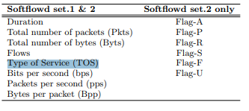

## **Refid: 746, KISS: Stochastic Packet Inspection Classifier for UDP Traffic**

Not Provided

## **Refid: 756, Detecting Advanced Persistent Threats Using Fractal Dimension Based Machine Learning Classification**

Not Provided

## **Refid: 759, Statistical Traffic Classification by Boosting Support Vector Machines**

source and destination IP address, source and destination port and transport protocol (TCP or UDP)

## **Refid: 762, Traffic Classification Using Visual Motifs: An Empirical Evaluation**

Not Provided

## **Refid: 763, Classifying SSH Encrypted Traffic with Minimum Packet Header Features Using Genetic Programming**

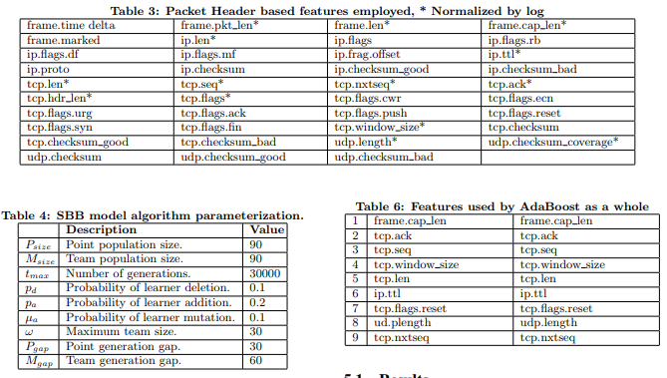

## **Refid: 778, A Functional Approach to Scanner Detection**

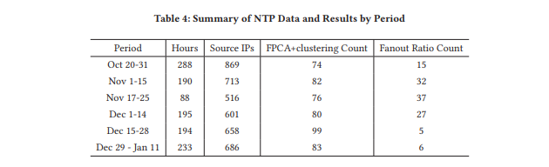

## **Refid: 782, Entropy Based Adaptive Flow Aggregation**

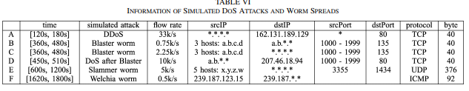

## **Refid: 785, Online Internet traffic monitoring system using spark streaming**

time stamp, source IP, source port, destination IP, destination port

## **Refid: 791, Online Traffic Classification Based on Co-training Method**

robust inter-packet time feature named “Netipt”

## **Refid: 799, Comparative analysis of five machine learning algorithms for IP traffic classification**

minimum, maximum, mean, variance and total values of no. of packets, average packets per second, packet size, duration, no. of conversations

## **Refid: 809, Cascaded classifier for improving traffic classification accuracy**

destination IP address, DNS domain name, port number, packet size and flow statistics

## **Refid: 810, Performance Comparison of Four Rule Sets: An Example for Encrypted Traffic Classification**

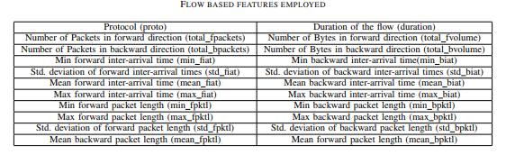

## **Refid: 816, A Statistical-Feature ML Approach to IP Traffic Classification Based on CUDA**

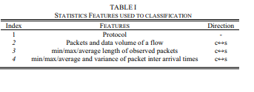

## **Refid: 818, A statistical-feature-based approach to internet traffic classification using Machine Learning**

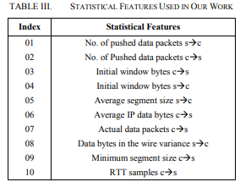

## **Refid: 829, A modular two-layer system for accurate and fast traffic classification**

Not Provided

## **Refid: 835, Internet traffic classification using MOEA and online refinement in voting on ensemble methods**

Not Provided

## **Refid: 837, Compact Hash Tables for High-Performance Traffic Classification on Multi-core Processors**

Source Port (SP), Destination Port (DP), Minimum Size of the first 4 packets (MinPS), Maximum Size of the first 4 packets (MaxPS), Average Size of the first 4 packets (APS), Variance of the first 4 packets (VPS), and Protocol (Prtl)

## **Refid: 841, SeLeCT: Self-Learning Classifier for Internet Traffic**

Not Provided

## **Refid: 849, Sub-flow packet sampling for scalable ML classification of interactive traffic**

minimum, mean, maximum, standard deviation and sum of the TCP/UDP payload lengths

## 

## **Refid: 852, Evaluating shallow and deep networks for secure shell (ssh)traffic analysis**

Not Provided

## **Refid: 854, How many packets are most effective for early stage traffic identification: An experimental study**

Not Provided

## **Refid: 855, BotDetector: A robust and scalable approach toward detecting malware-infected devices**

Not Provided

## **Refid: 859, Online Internet Traffic Measurement and Monitoring Using Spark Streaming**

Not Provided

## **Refid: 866, Multi-layer Anomaly Detection for Internet Traffic Based on Data Mining**

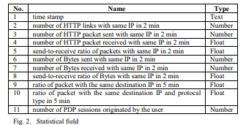

## **Refid: 870, A novel aggregated statistical feature based accurate classification for internet traffic**

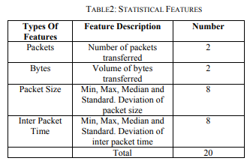

## **Refid: 873, Efficient Methods for Early Protocol Identification**

Not Provided

## **Refid: 882, Genetic optimization and hierarchical clustering applied to encrypted traffic identification**

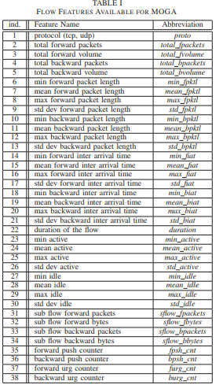

## **Refid: 890, Anonymity Services Tor, I2P, JonDonym: Classifying in the Dark (Web)**

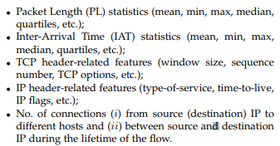

## **Refid: 892, Identifying Key Features for P2P Traffic Classification**

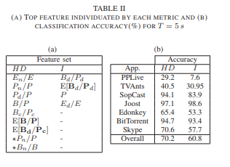

## **Refid: 895, Real-Time Classification of Multimedia Traffic Using FPGA**

IP protocol, packet size and port numbers

## **Refid: 903, Early classification of residential networks traffic using C5.0 machine learning algorithm**

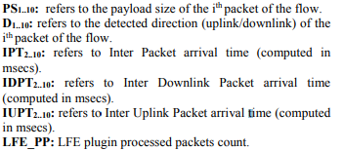

## 

## **Refid: 904, Hybrid Traffic Classification Approach Based on Decision Tree**

average packet size, flow duration, bytes per flow, packets per flow, and Root Mean Square (RMS) packet size

## **Refid: 905, The Impact of Evasion on the Generalization of Machine Learning Algorithms to Classify VoIP Traffic**

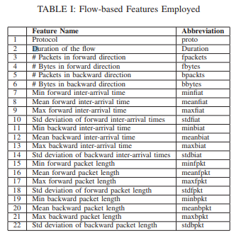

## **Refid: 919, Internet Traffic Classification Using Constrained Clustering**

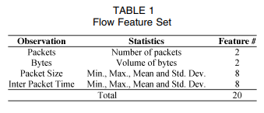

## **Refid: 926, Hierarchical RBF Neural Network Using for Early Stage Internet Traffic Identification**

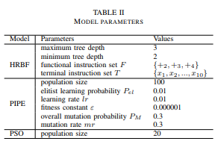

## **Refid: 928, Noise-resistant Statistical Traffic Classification**

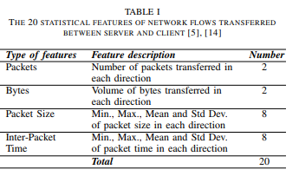

## **Refid: 930, Internet traffic classification based on associative classifiers**

Not Provided

## **Refid: 934, Practical machine learning based multimedia traffic classification for distributed QoS management**

Not Provided

## **Refid: 938, Traffic classification using cost based decision tree**

Not Provided

## **Refid: 951, A hybrid heuristics-statistical peer-to-peer traffic classifier**

Not Provided

## **Refid: 958, Experiments on detection of Denial of Service attacks using Naive Bayesian classifier**

back,buffer_overflow,ftp_write,guess_passwd,imap,ipsweep,land,loadmodule,multihop,neptune,nmap,normal,perl,phf,pod,portsweep,rootkit,satan,smurf,spy,teardrop,warezclient,warezmaster.  
duration: continuous.  
protocol_type: symbolic.  
service: symbolic.  
flag: symbolic.  
src_bytes: continuous.  
dst_bytes: continuous.  
land: symbolic.  
wrong_fragment: continuous.  
urgent: continuous.  
hot: continuous.  
num_failed_logins: continuous.  
logged_in: symbolic.  
num_compromised: continuous.  
root_shell: continuous.  
su_attempted: continuous.  
num_root: continuous.  
num_file_creations: continuous.  
num_shells: continuous.  
num_access_files: continuous.  
num_outbound_cmds: continuous.  
is_host_login: symbolic.  
is_guest_login: symbolic.  
count: continuous.  
srv_count: continuous.  
serror_rate: continuous.  
srv_serror_rate: continuous.  
rerror_rate: continuous.  
srv_rerror_rate: continuous.  
same_srv_rate: continuous.  
diff_srv_rate: continuous.  
srv_diff_host_rate: continuous.  
dst_host_count: continuous.  
dst_host_srv_count: continuous.  
dst_host_same_srv_rate: continuous.  
dst_host_diff_srv_rate: continuous.  
dst_host_same_src_port_rate: continuous.  
dst_host_srv_diff_host_rate: continuous.  
dst_host_serror_rate: continuous.  
dst_host_srv_serror_rate: continuous.  
dst_host_rerror_rate: continuous.  
dst_host_srv_rerror_rate: continuous.

## **Refid: 959, Seq2Img: A sequence-to-image based approach towards IP traffic classification using convolutional neural networks**

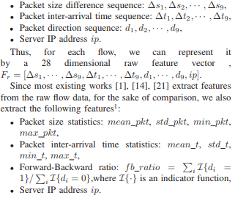

## **Refid: 962, Traffic Classification through Joint Distributions of Packet-Level Statistics**

mean and standard deviation of PS or of IPT, minumum, maximum, quartiles of their distributions, etc..

## **Refid: 963, User traffic classification for proxy-server based internet access control**

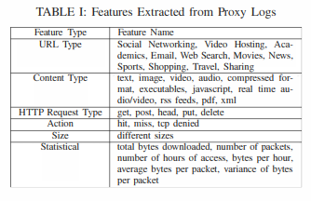

## **Refid: 973, Detecting and diagnosing anomalies in cellular networks using Random Neural Networks**

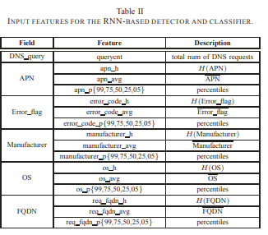

## **Refid: 974, Skype Traffic Classification Using Cost Sensitive Algorithms**

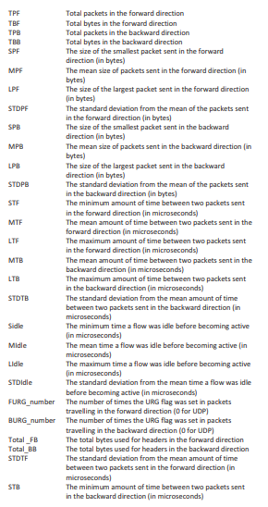

## **Refid: 978, Intelligent IoT Traffic Classification Using Novel Search Strategy for Fast-Based-Correlation Feature Selection in Industrial**

back,buffer_overflow,ftp_write,guess_passwd,imap,ipsweep,land,loadmodule,multihop,neptune,nmap,normal,perl,phf,pod,portsweep,rootkit,satan,smurf,spy,teardrop,warezclient,warezmaster.  
duration: continuous.  
protocol_type: symbolic.  
service: symbolic.  
flag: symbolic.  
src_bytes: continuous.  
dst_bytes: continuous.  
land: symbolic.  
wrong_fragment: continuous.  
urgent: continuous.  
hot: continuous.  
num_failed_logins: continuous.  
logged_in: symbolic.  
num_compromised: continuous.  
root_shell: continuous.  
su_attempted: continuous.  
num_root: continuous.  
num_file_creations: continuous.  
num_shells: continuous.  
num_access_files: continuous.  
num_outbound_cmds: continuous.  
is_host_login: symbolic.  
is_guest_login: symbolic.  
count: continuous.  
srv_count: continuous.  
serror_rate: continuous.  
srv_serror_rate: continuous.  
rerror_rate: continuous.  
srv_rerror_rate: continuous.  
same_srv_rate: continuous.  
diff_srv_rate: continuous.  
srv_diff_host_rate: continuous.  
dst_host_count: continuous.  
dst_host_srv_count: continuous.  
dst_host_same_srv_rate: continuous.  
dst_host_diff_srv_rate: continuous.  
dst_host_same_src_port_rate: continuous.  
dst_host_srv_diff_host_rate: continuous.  
dst_host_serror_rate: continuous.  
dst_host_srv_serror_rate: continuous.  
dst_host_rerror_rate: continuous.  
dst_host_srv_rerror_rate: continuous.

## 

## **Refid: 980, Certificate-aware encrypted traffic classification using Second-Order Markov Chain**

Not Provided

## **Refid: 981, Accurate classification of P2P traffic by clustering flows**

Not Provided+

## **Refid: 984, Privacy-Preserving Internet Traffic Publication**

(srcIP, srcPort, destIP, destPort, Protocol+

## **Refid: 985, A multi-variate classification approach for the detection of illicit traffic**

Not Provided

## **Refid: 992, Mining Mobile Internet Packets for Malware Detection**

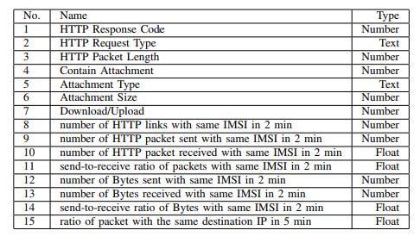

## **Refid: 997, Impact of Asymmetric Routing on Statistical Traffic Classification**

Not Provided

## **Refid: 999, An investigation on identifying SSL traffic**

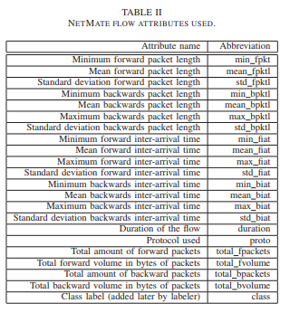

## **Refid: 1001, A novel approach for internet traffic classification based on multi-objective evolutionary fuzzy classifiers**

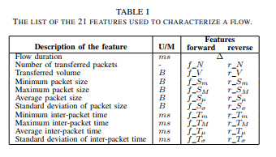

## **Refid: 1003, Probabilistic Neural Network based attack traffic classification**

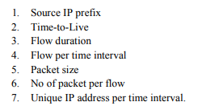

## **Refid: 1005, MINETRAC: Mining flows for unsupervised analysis amp; semi-supervised classification**

Not Provided

## **Refid: 1012, Application feature extraction by using both dynamic binary tracking and statistical learning**

Not Provided

## **Refid: 1018, On the use of Sub-Space Clustering amp; Evidence Accumulation for traffic analysis amp; classification**

protocol, flow duration, flow volume in bytes and packets, packet length (minimum, mean, maximum, and standard deviation), and inter-arrival time between packets (minimum, mean, maximum, and standard deviation)

## **Refid: 1032, Unusual internet traffic detection at network edge**

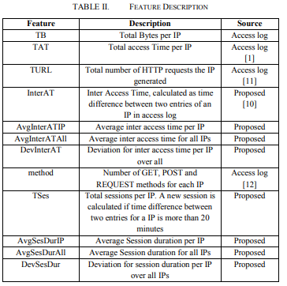

## **Refid: 1056, Classification of unknown mobile web traffic based on correlation coefficient measurement**

Not Provided

## **Refid: 1062, BitCoding: Protocol Type Agnostic Robust Bit Level Signatures for Traffic Classification**

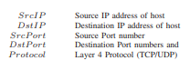

## **Refid: 1065, On the Impact of Packet Inter Arrival Time for Early Stage Traffic Identification**

Inter arrival time, Packet sizes

## **Refid: 1068, ProDigger: Towards Robust Automatic Network Protocol Fingerprint Learning via Byte Embedding**

Number of packets truncated (P), Number of bytes truncated (B),, Minimal length threshold (L), Number of clusters (K), Number of packets required (N)

## **Refid: 1071, Machine learning based encrypted traffic classification: Identifying SSH and Skype**

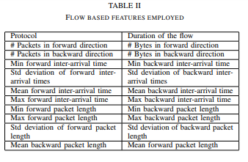

## **Refid: 1077, A cascade forest approach to application classification of mobile traces**

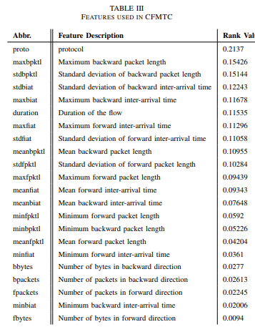

## **Refid: 1078, Robust Traffic Classification with Mislabelled Training Samples**

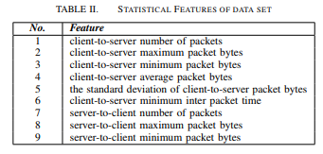

## **Refid: 1080, Internet traffic data categorization using particle of swarm optimization algorithm**

Not Provided

## **Refid: 1084, Hashdoop: A MapReduce framework for network anomaly detection**

Not Provided

## **Refid: 1086, Accelerating Decision Tree Based Traffic Classification on FPGA and Multicore Platforms**

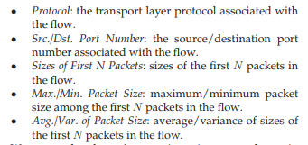

## **Refid: 1091, High-throughput hash-based online traffic classification engines on FPGA**

destination port number, average packet size

## **Refid: 1093, Simple CART based real-time traffic classification engine on FPGAs**

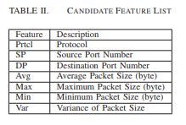

## **Refid: 1094, Automatically mining application signatures for lightweight deep packet inspection**

Not Provided

## **Refid: 1095, Sparse-Clustered Network with Selective Decoding for Internet Traffic Classification**

Not Provided

## **Refid: 1096, Traffic Classification Based on Zero-Length Packets**

Not Provided

## **Refid: 1098, High-throughput traffic classification on multi-core processors**

Src Port (SP) Dst. Port (DP) Avg. Pkt. Size (APS) Max. Pkt. Size (MaxPS) Min. Pkt. Size (MinPS) App. Class

## **Refid: 1099, Large traffic flows classification method**

Not Provided

## **Refid: 1104, Optimal supervised feature extraction in internet traffic classification**

Not Provided

## **Refid: 1107, Machine learning based internet traffic recognition with statistical approach**

Packets/sec, Mean IP packet length, Mean IP payload length, Byttes/Flow, Flow duration, Mean IAT, Bytes/sec, SD of IP packket length, SD of IAT, SD of IP

## **Refid: 1110, Internet traffic classification using machine learning approach: Datasets validation issues**

inter-arrival time and packet length

## **Refid: 1111, Internet Traffic Classification Using Score Level Fusion of Multiple Classifier**

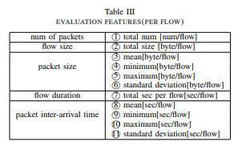

## **Refid: 1112, Lightweight Internet Traffic Classification: A Subject-Based Solution with Word Embeddings**

destination IP, destination port, , Real-time Transport Protocol header fields), number of Multi Protocol Label Switching labels, next hop IP address, the output interface

## **Refid: 1118, IP traffic classification in NFV: A benchmarking of supervised Machine Learning algorithms**

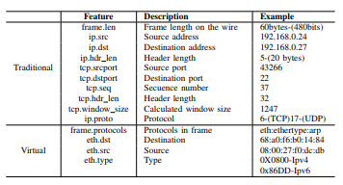

## **Refid: 1120, Low complexity, high performance neuro-fuzzy system for Internet traffic flows early classification**

Not Provided

## **Refid: 1151, Analysis of VBR coded VoIP for traffic classification**

mean (PMean), median(PMedian), mode (PMode), minimum (PMin), maximum (PMax), standard deviation (PStddev), bit (H0), pair (H1), nibble (H2) and byte (H3)

## **Refid: 1157, Application traffic classification using statistic signature**

port number, flow duration, inter-packet arrival time, packet size

## **Refid: 1160, Early Stage Internet Traffic Identification Using Data Gravitation Based Classification**

Packet size, Average, Standard deviation and Maximum and minimum

## **Refid: 1166, Detection of SIP signaling attacks using two-tier fine grained model for VoIP**

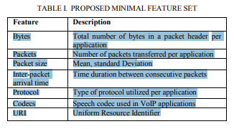

## **Refid: 1180, A Framework for QoS-aware Traffic Classification Using Semi-supervised Machine Learning in SDNs**

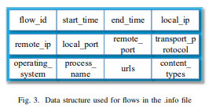

## **Refid: 1184, Internet traffic classification based on Min-Max Ensemble Feature Selection**

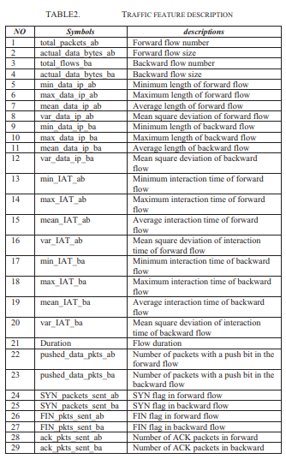

## **Refid: 1185, Using Entropy to Classify Traffic More Deeply**

Not Provided

## **Refid: 1186, Traffic classification using probabilistic neural networks**

minimum value, maximum value, average value, variance of packet size, inter-arrival time, The number of forward/backward packets, the rate of forward/backward packet number and the rate

of forward/backward bytes.

## **Refid: 1190, Pushing intelligence to the network edge**

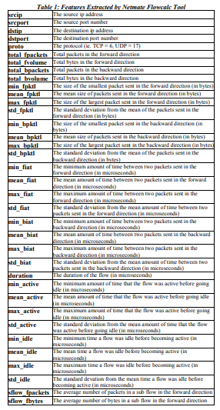

## 

## **Refid: 1194, Cooperative learning for online in-network performance monitoring**

Not Provided

## **Refid: 1195, Online hybrid internet traffic classification algorithm based on signature statistical and port methods to identify internet**

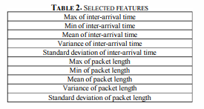

## **Refid: 1198, Minimal dataset for Network Intrusion Detection Systems via dimensionality reduction**

back,buffer_overflow,ftp_write,guess_passwd,imap,ipsweep,land,loadmodule,multihop,neptune,nmap,normal,perl,phf,pod,portsweep,rootkit,satan,smurf,spy,teardrop,warezclient,warezmaster.  
duration: continuous.  
protocol_type: symbolic.  
service: symbolic.  
flag: symbolic.  
src_bytes: continuous.  
dst_bytes: continuous.  
land: symbolic.  
wrong_fragment: continuous.  
urgent: continuous.  
hot: continuous.  
num_failed_logins: continuous.  
logged_in: symbolic.  
num_compromised: continuous.  
root_shell: continuous.  
su_attempted: continuous.  
num_root: continuous.  
num_file_creations: continuous.  
num_shells: continuous.  
num_access_files: continuous.  
num_outbound_cmds: continuous.  
is_host_login: symbolic.  
is_guest_login: symbolic.  
count: continuous.  
srv_count: continuous.  
serror_rate: continuous.  
srv_serror_rate: continuous.  
rerror_rate: continuous.  
srv_rerror_rate: continuous.  
same_srv_rate: continuous.  
diff_srv_rate: continuous.  
srv_diff_host_rate: continuous.  
dst_host_count: continuous.  
dst_host_srv_count: continuous.  
dst_host_same_srv_rate: continuous.  
dst_host_diff_srv_rate: continuous.  
dst_host_same_src_port_rate: continuous.  
dst_host_srv_diff_host_rate: continuous.  
dst_host_serror_rate: continuous.  
dst_host_srv_serror_rate: continuous.  
dst_host_rerror_rate: continuous.  
dst_host_srv_rerror_rate: continuous.

## **Refid: 1204, A New Feature Selection Method for Internet Traffic Classification Using ML**

Not Provided

## **Refid: 1205, Abacus: Accurate behavioral classification of P2P-TV traffic**

Not Provided

## **Refid: 1217, Efficient application identification and the temporal and spatial stability of classification schema**

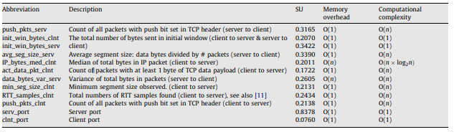

## **Refid: 1219, Application-based feature selection for Internet traffic classification**

Size of data packets: and Port Numbers

## **Refid: 1225, Exploiting unlabeled data to improve peer-to-peer traffic classification using incremental tri-training method**

Not Provided

## **Refid: 1226, Histogram-based traffic anomaly detection**

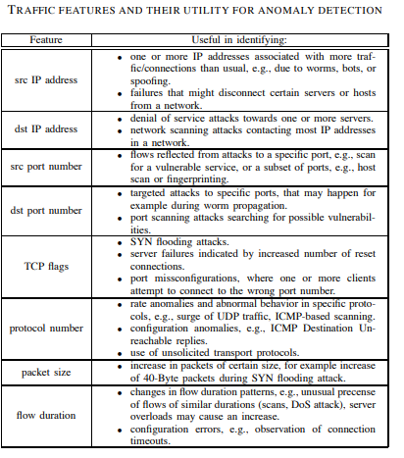

## **Refid: 1227, Classification of traffic flows into QoS classes by unsupervised learning and KNN clustering**

Packet level features: packet length statistics (maximum, minimum, mean, variance)

flow level features: statistics of number of packets per flow, number of bytes per flow,

flow duration, interarrival times,

TCP connection level features: statistics of packets per TCP connection, bytes per

connection, connection duration

## **Refid: 1228, Supervised learning real-time traffic classifiers**

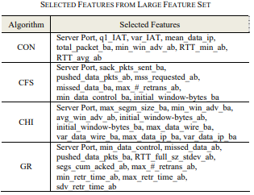

## **Refid: 1230, Support Vector Machines for TCP traffic classification**

Not Provided

## **Refid: 1262, Intelligent IP traffic/flow classification system**

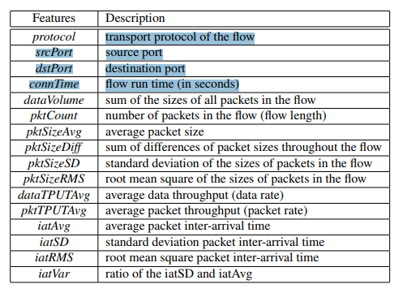

## **Refid: 1265, K-dimensional trees for continuous traffic classification**

destination port, n packet sizes, L7 label), first n packet size

## **Refid: 1277, An automatic application signature construction system for unknown traffic**

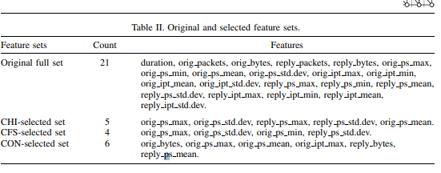

## **Refid: 1307, Monitoring, analysis, and filtering system for purifying network traffic of known and unknown malicious content**

Not Provided

## **Refid: 1310, A semi-supervised clustering method for P2P traffic classification**

srcIP, desIP, Prot, srcPort, desPort

## **Refid: 1311, Internet traffic classification based on fuzzy kernel K-means clustering**

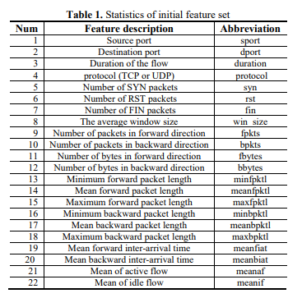

## **Refid: 1312, Analysis of the impact of sampling on NetFlow traffic classification**

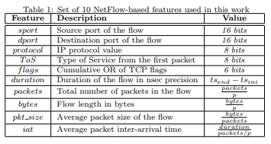

## **Refid: 1314, Online wireless mesh network traffic classification using machine learning**

duration, bytes transferred, mean packet interarrival time, and mean packet size

## **Refid: 1316, Online internet traffic classification based on proximal SVM**

Not Provided

## **Refid: 1317, Real-time encrypted traffic identification using machine learning**

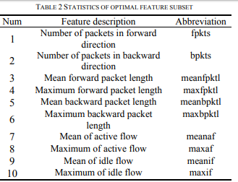

## **Refid: 1330, Early identification of peer-to-peer traffic**

the number of packets in the flow, the average packet size, the count of Push flags, inter-arrival time statistic

## **Refid: 1336, High-performance intrusion detection using OptiGrid clustering and grid-based labelling**

back,buffer_overflow,ftp_write,guess_passwd,imap,ipsweep,land,loadmodule,multihop,neptune,nmap,normal,perl,phf,pod,portsweep,rootkit,satan,smurf,spy,teardrop,warezclient,warezmaster.  
duration: continuous.  
protocol_type: symbolic.  
service: symbolic.  
flag: symbolic.  
src_bytes: continuous.  
dst_bytes: continuous.  
land: symbolic.  
wrong_fragment: continuous.  
urgent: continuous.  
hot: continuous.  
num_failed_logins: continuous.  
logged_in: symbolic.  
num_compromised: continuous.  
root_shell: continuous.  
su_attempted: continuous.  
num_root: continuous.  
num_file_creations: continuous.  
num_shells: continuous.  
num_access_files: continuous.  
num_outbound_cmds: continuous.  
is_host_login: symbolic.  
is_guest_login: symbolic.  
count: continuous.  
srv_count: continuous.  
serror_rate: continuous.  
srv_serror_rate: continuous.  
rerror_rate: continuous.  
srv_rerror_rate: continuous.  
same_srv_rate: continuous.  
diff_srv_rate: continuous.  
srv_diff_host_rate: continuous.  
dst_host_count: continuous.  
dst_host_srv_count: continuous.  
dst_host_same_srv_rate: continuous.  
dst_host_diff_srv_rate: continuous.  
dst_host_same_src_port_rate: continuous.  
dst_host_srv_diff_host_rate: continuous.  
dst_host_serror_rate: continuous.  
dst_host_srv_serror_rate: continuous.  
dst_host_rerror_rate: continuous.  
dst_host_srv_rerror_rate: continuous.

## **Refid: 1358, Feed-forward neural networks for accurate and robust traffic classification**

Not Provided

## **Refid: 1367, Feature selection for optimizing traffic classification**

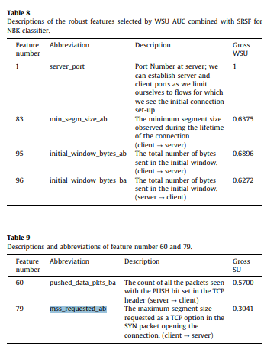

## **Refid: 1370, Peer to peer botnet detection based on flow intervals**

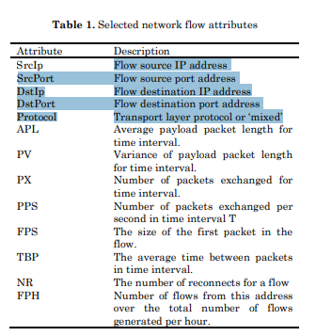

## **Refid: 1372, Machine learning-based classification of encrypted internet traffic**

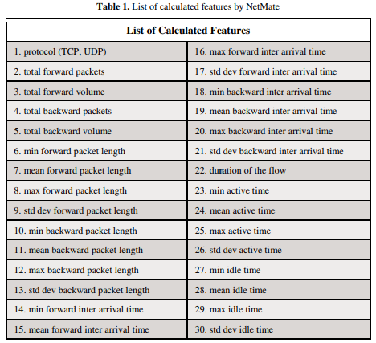

## **Refid: 1397, Traffic classification model based on integration of multiple classifiers**

Not Provided

## **Refid: 1402, SSPC algorithm based on three different methods for online Skype traffic classification**

Max of Interarrival time Min of Interarrival time Mean of Interarrival time Variance of Interarrival time Standard deviation of Interarrival time Max of packet length Min of Packet length Mean of Packet length Variance of Packet length Standard deviation of Packet length

## **Refid: 1404, Encrypted Traffic Classification Based on an Improved Clustering Algorithm**

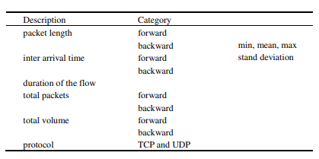

## **Refid: 1407, Out-of-sequence traffic classification based on improved dynamic time warping**

Number of Packets, flow duration, packet size and inter-arrival time

## **Refid: 1408, Towards fingerprinting malicious traffic**

Not Provided

## **Refid: 1413, Automated Dataset Generation for Training Peer-to-Peer Machine Learning Classifiers**

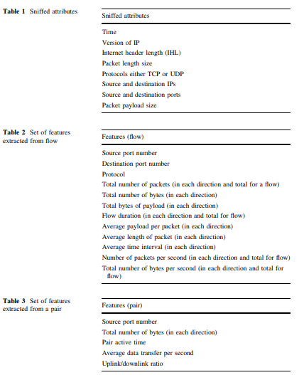

## **Refid: 1414, Retraining mechanism for on-line peer-to-peer traffic classification**

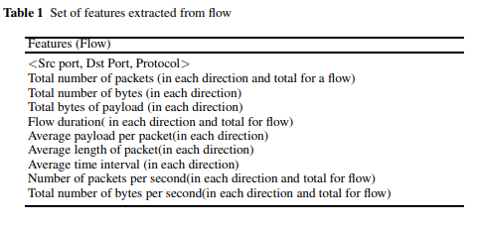

## **Refid: 1418, Classification Research on SSL Encrypted Application**

packet length, packet interarrival time, and the direction of a flow

## **Refid: 1420, Automatically mining application signatures for lightweight deep packet inspection**

packet inter-arrival time, packet size, flow duratio

## 

## **Refid: 1423, Application traffic classification at the early stage by characterizing application rounds**

Not Provided

## **Refid: 1428, Toward an efficient and scalable feature selection approach for internet traffic classification**

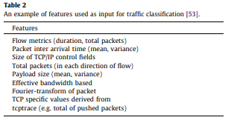

## **Refid: 1442, Classifying peer-to-peer applications using imbalanced concept-adapting very fast decision tree on IP data stream**

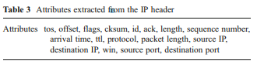

## **Refid: 1449, Traffic classification model based on fusion of multiple classifiers with flow preference**

low port number; high port number; Flow duration; Transport protocol used (TCP/UDP); TCPflags1; TCPflags2; pps; bps; Mean packets arrived time; Biodirection Packets ratio; Biodirection Bytes ratio; Biodirection packets; Biodirection bytes; tos; Mean packet length

## **Refid: 1453, Zero-day traffic identification**

number of packets, number of bytes, packet size, inter-packet time

## **Refid: 1470, A comparison of improving multi-class imbalance for internet traffic classification**

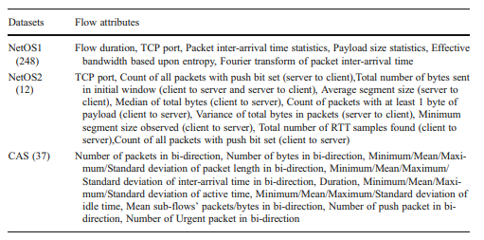

## **Refid: 1471, Internet traffic clustering with side information**

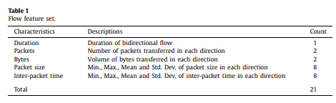

## **Refid: 1490, Selection of on-line features for peer-to-peer network traffic classification**

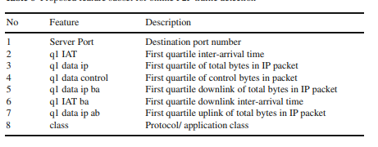

## 

## **Refid: 1495, Feature evaluation for early stage internet traffic identification**

Packet Sizes, The First and the Second Order Differences, Average, Standard Deciation, MAx and Min, Geometric Mean and Variance

## **Refid: 1498, High-performance traffic classification on GPU**

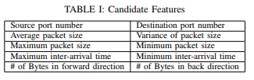

## **Refid: 1506, Hybrid P2P traffic classification with heuristic rules and machine learning**

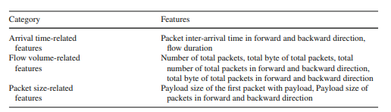

## **Refid: 1534, Automatic traffic classification using machine learning algorithm for policy-based routing in UMTS–WLAN interworking**

packet level (packet length, byte counts, idle time), flow level (flow duration, data volume per flow, number of packets per flow), connection level (window sizes, throughput distribution, connection duration), and connection features (packet interarrival statistics)

## **Refid: 1540, Effective packet number for early stage internet traffic identification**

Not Provided

## **Refid: 1554, Anomaly detection based on efficient Euclidean projection**

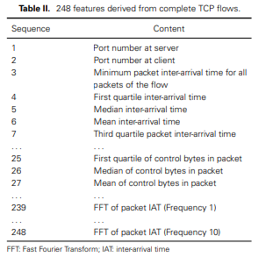

## **Refid: 1555, Statistical user behavior detection and QoE evaluation for thin client services**

up-link packet number;

up-link average packet size;

up-link average bandwidth usage;

down-link packet number;

down-link average packet size;

down-link average bandwidth usage;

## **Refid: 1557, Robust representation for domain adaptation in network security**

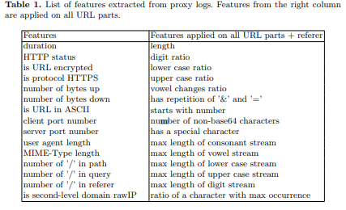

## **Refid: 1561, Anomaly detection in traffic using L1-norm minimization extreme learning machine**

Not Provided

## **Refid: 1564, An Autonomic Traffic Classification System for Network Operation and Management**

IP addresses, IP, Port, Protocol, NetFlow v5 features, average packet

size, flow time, flow rate, inter-arrival time

## **Refid: 1571, MTRAC - Discovering M2M devices in cellular networks from coarse-grained measurements**

Sum of upload volume, Sum of download volume, Sum of connection time, Histogram per day,

Strongest spikes upload volume, Strongest spikes download volume, Strongest spikes connection time, Strongest spikes time between starts

## **Refid: 1575, Designing an Internet Traffic Predictive Model by Applying a Signal Processing Method**

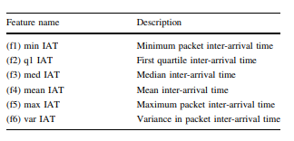

## **Refid: 1576, How Robust Can a Machine Learning Approach Be for Classifying Encrypted VoIP?**

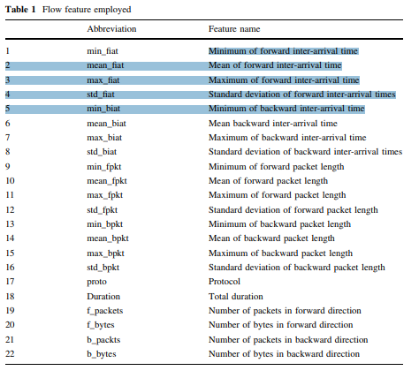

## **Refid: 1585, On Internet Traffic Classification: A Two-Phased Machine Learning Approach**

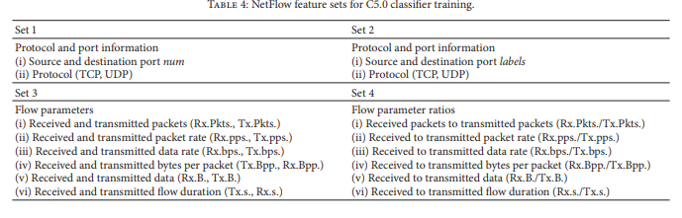

## **Refid: 1590, Modelling the multi-layer artificial neural network for internet traffic forecasting: The model selection design issues**

Not Provided

## **Refid: 1591, Spot the hotspot: Wi-Fi hotspot classification from internet traffic**

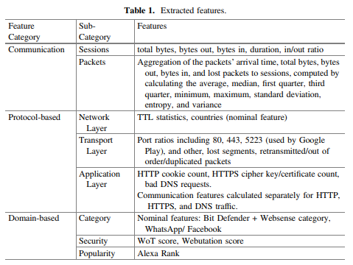

## **Refid: 1607, Effectiveness of Statistical Features for Early Stage Internet Traffic Identification**

Payload size, Average, Standard deviation, Maximum and minimum, Geometric mean, Variance

## **Refid: 1619, A preliminary performance evaluation of K-means, KNN and em unsupervised machine learning methods for network flow**

Not Provided

## **Refid: 1635, Classification of VoIP and non-VoIP traffic using machine learning approaches**

Packet Length, Delta Time, Cumulative Byte and Relative Time

## **Refid: 1636, DBStream: A holistic approach to large-scale network traffic monitoring and analysis**

Not Provided

## **Refid: 1652, Effective Feature Selection for 5G im Applications Traffic Classification**

Mean_fpktl,

Max_fpktl,

Std_fpktl,

Min_bpktl,

Mean_bpktl,

Max_bpktl,

Std_bpktl,

Max_fiat,

Total_fpackets,

Max_fpktl

## **Refid: 1655, Classification of network traffic using fuzzy clustering for network security**

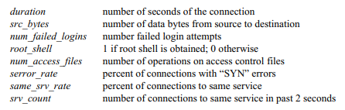

## **Refid: 1657, A search for computationally efficient supervised learning algorithms of anomalous traffic**

back,buffer_overflow,ftp_write,guess_passwd,imap,ipsweep,land,loadmodule,multihop,neptune,nmap,normal,perl,phf,pod,portsweep,rootkit,satan,smurf,spy,teardrop,warezclient,warezmaster.  
duration: continuous.  
protocol_type: symbolic.  
service: symbolic.  
flag: symbolic.  
src_bytes: continuous.  
dst_bytes: continuous.  
land: symbolic.  
wrong_fragment: continuous.  
urgent: continuous.  
hot: continuous.  
num_failed_logins: continuous.  
logged_in: symbolic.  
num_compromised: continuous.  
root_shell: continuous.  
su_attempted: continuous.  
num_root: continuous.  
num_file_creations: continuous.  
num_shells: continuous.  
num_access_files: continuous.  
num_outbound_cmds: continuous.  
is_host_login: symbolic.  
is_guest_login: symbolic.  
count: continuous.  
srv_count: continuous.  
serror_rate: continuous.  
srv_serror_rate: continuous.  
rerror_rate: continuous.  
srv_rerror_rate: continuous.  
same_srv_rate: continuous.  
diff_srv_rate: continuous.  
srv_diff_host_rate: continuous.  
dst_host_count: continuous.  
dst_host_srv_count: continuous.  
dst_host_same_srv_rate: continuous.  
dst_host_diff_srv_rate: continuous.  
dst_host_same_src_port_rate: continuous.  
dst_host_srv_diff_host_rate: continuous.  
dst_host_serror_rate: continuous.  
dst_host_srv_serror_rate: continuous.  
dst_host_rerror_rate: continuous.  
dst_host_srv_rerror_rate: continuous.

## **Refid: 1658, Multi-stage feature selection for on-line flow peer-to-peer traffic identification**

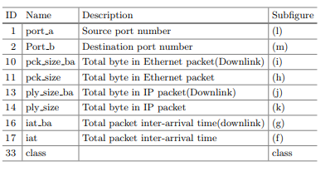

## **Refid: 1661, Link-layer device type classification on encrypted wireless traffic with COTS radios**

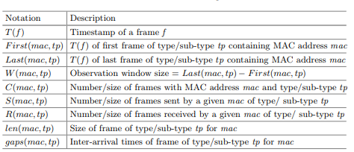

## **Refid: 1671, P2P and P2P botnet traffic classification in two stages**

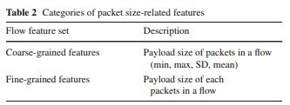

## **Refid: 1677, Imbalanced traffic identification using an imbalanced data gravitation-based classification model**

Not Provided

## **Refid: 1680, Optimizing an artificial immune system algorithm in support of flow-Based internet traffic classification**

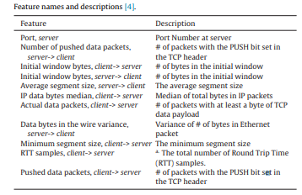

## 

## **Refid: 1683, Efficient and robust feature extraction and selection for traffic classification**

Minimum packet size, maximum packet size, quartiles of packet sizes, minimum packet size as fraction of max and the first five modes; total number of bytes; the number of transitions between the transaction mode and bulk transfer mode; interarrival time (ITA); idle time in bulk mode and in transaction mode; flow duration.

## **Refid: 1691, A novel approach for internet traffic classification based on multi-objective evolutionary fuzzy classifiers**

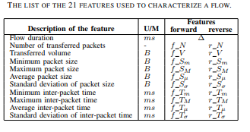

## **Refid: 1706, Ensemble network traffic classification: Algorithm comparison and novel ensemble scheme proposal**

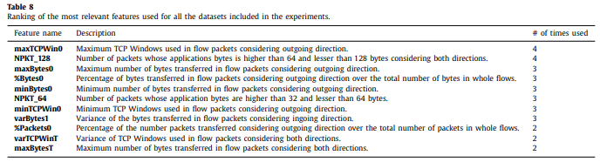

## **Refid: 1718, Distributed detection of zero-day network traffic flows**

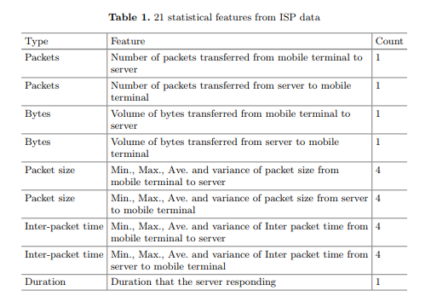

## **Refid: 1719, Traffic classification based on incremental learning method**

Not Provided

## **Refid: 1735, An efficient feature generation approach based on deep learning and feature selection techniques for traffic classification**

Not Provided

## **Refid: 1740, A BasisEvolution framework for network traffic anomaly detection**

Not Provided

## **Refid: 1741, Tor anonymous traffic identification based on gravitational clustering**

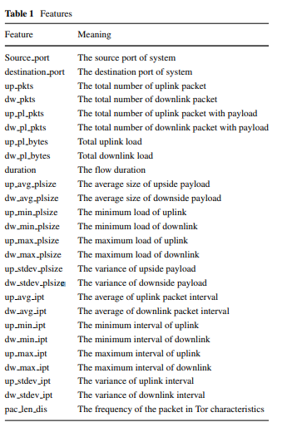

## **Refid: 1742, Detecting malware-infected devices using the HTTP header patterns**

Not Provided

## **Refid: 1745, A scalable distributed machine learning approach for attack detection in edge computing environments**

